MAIN SESSION 4
Lead: Chester
Song 1: Hymn of the Saviour Hymn Of The Saviour (Live) // Emu Music
Song 2: I Will Trust My Saviour Jesus CityAlight – I Will Trust My Saviour Jesus (Live)
Closing Song: Let the Nations Be Glad

Hymn of the Saviour: Emu Music
Keys intro
[Intro]
F Am C2 C2

[Verse 1]
Am F
From the chaos of darkness
C G
Your word shaped the earth
Am F C
In your image a people made
Am F
But we traded perfection
C G
The truth for a lie
Am F C
And your glory was veiled in shame

[Verse 2]
F C
But a promise made
G Am
A blessing you gave
F C G
To a people of your name
F C
For this broken world
Em Am
A saviour foretold
F G
To bear all our grief and pain

F Am C C
F Am C C

[Verse 3] Build Up
Am F
When the heavenly saviour
C G
Descended his throne
Am F C
All my sin on his shoulders laid
Am F
And to win our redemption
C G
He suffered and died
Am F C
For the sake of my guilt and shame

[Verse 4]
F C
Oh the price he paid
G Am
In taking my place
F C G
so that death was overcome
F C
For the king of love
Em Am
Burst forth from the grave
F G
Proclaiming the victory won

F Am C C
F Am C C

[Verse 5] (Soft)
Am F
At the end of the ages
C G
The world passed away
Am F C
I will gaze on my saviour's face
Am F
When my heart is perfected
C G
Free from my sin
Am F C (build)
I will rest in your glorious grace
Build to top
[Verse 6]
F C
For the song we raise
G Am
The works of our hands
F C G
Are in service of the king
F C
When a thousand tounges
Em Am
Cry "Glory to God"
F G F
Forever his praise we'll sing
F C
For the song we raise
G Am
The works of our hands
F C G
Are in service of the king
F C
When a thousand tounges
Em Am
Cry "Glory to God"
F G Am
Forever his praise we'll sing
F G F
Forever his praise we'll sing
Am C C
F Am C End

Closing song: I will trust my Savior Jesus C

[Intro]

| C / / | Am / / | F / / | C / / |
| C / / | Am / / | F / / | C / / |

[Verse 1]
C Am
I will trust my Saviour Jesus
F C
When my darkest doubts befall
Am F
Trust Him when to simply trust Him
C G C
Seems the hardest thing of all

[Instrumental]

| C / / | Am / / | F / / | C / / |

[Verse 2]
C Am
I will trust my Saviour Jesus
F C
Trust Him when my strength is small
Am F
For I know the shield of Jesus
C G C
Is the safest place of all

[Chorus]
F C
Jesus, only Jesus
Am G
Help me trust You more and more
F C
Jesus, only Jesus
Am G F
May my heart be ever Yours

[Verse 3]
C Am
I will trust my Saviour Jesus
F C
He has said His way is best
Am F
And I know the path He's chosen
C G C
Leads to everlasting rest

CHORUS X2

[Instrumental]

| C / / | G / / | Dm / / | Am / / |
| F / / | C / / | G / / | C / / |

[Bridge]
C G
Oh on that cross
Dm Am
How it was seen
F C
I can go now ever trusting
G C
In the One who died for me
C G
What could I bring
Dm Am
For Your gift is complete
F C
So I trust You simply trust You
G C
Lord with every part of me X3 BUILD
(Build-up)

CHORUS (*Quiet down!, x2 even softer)

Let The Nations Be Glad

LET THE NATIONS BE GLAD
[Intro]
C F C F

[Verse 1]
C
Let the glory of the Lord forever be our
joy
G F
May redemption be the theme of our song
C
For by grace we have been saved

And by grace we shall proclaim
C G
To the corners of the earth that Christ
F G
has come

[Chorus]
F C F G
Let the nations be glad, let the people
Am
rejoice
F C G
For salvation belongs to our God
F C
Let the whole earth be filled with the
F G Am
praises of the Lord
F C G
For salvation belongs to our God
F G C F C F
Let the nations be glad

[Verse 2]
C
Through the ages gone before

Through the trial and the sword

Many saints and martyrs conquered though
G F
they died
C
Still we're holding out the cross

Crossing oceans suffering loss
C G
Shall endure all things to win the crown
F G
of life

CHORUS

[Verse 3]
C
As your holy church goes forth, in the
Holy Spirit's power
G
With the glories of the Gospel to explain
F
Am
Now we pray Your kingdom come
G/B C
And we pray Your will be done
F G
For the honor and the glory of Your
Am
name

CHORUS x2 (first time till 2nd last line)

MAIN SESSION 6
Lead: Chester
Song 1: This Life I Live
Song 2: In This Book
Closing Song: Undivided Undivided

This Life I Live

[Intro]
| C | Gsus4 | F | C | x2

[Verse 1]
C Gsus4
This life I live is not my own
F Gsus4 C
For my Redeemer paid the price
C Gsus4
He took it to be His alone
F Gsus4 C
To be His treasure and His prize
Am F C
The things of earth I leave behind
Am F Gsus4
To live in worship of my King
G Dm
His is the right to rule my life
F Gsus4 C
Mine is the joy to live for Him

[Interlude]
| C | G | F | C | x2

[Verse 2]
C Gsus4
I died to sin upon the cross
F Gsus4 C
I'm bound to Jesus in His death
C Gsus4
The old is gone and now I must
F Gsus4 C
Rely on Him for every breath
Am F C
With every footstep that I tread
Am F Gsus4
What mysteries He has in store
G Dm
I cannot know what lies ahead
F Gsus4 C
But know that He has gone before

[Interlude]
| C | G | F | C |

[Verse 3]
C Gsus4
There is a voice that pierced the grave
F Gsus4 C
A power that rolled the stone away
C Gsus4
A sound of life, I know I'm saved
F Gsus4 C
The voice of God has called my name
Am F C
[[So I will rise, and in the air
Am F Gsus4
Behold the glory of the King
G Dm
I will not fear to meet Him there
F Gsus4 C
I know my life is hid with Him ]] x2

[Outro]
| C | G | F | C |

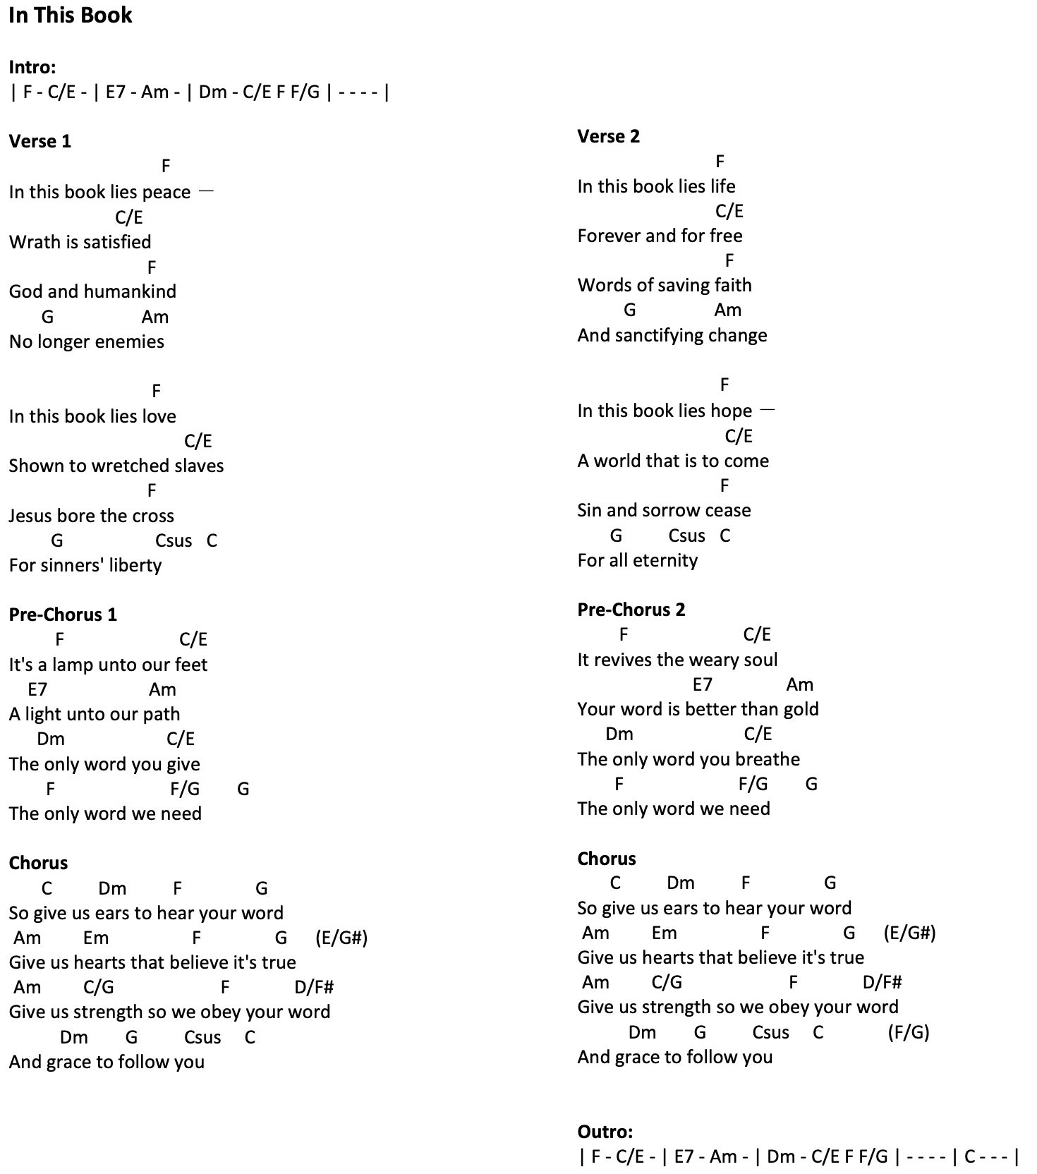
In This Book

Undivided by Emu Music (C)

[Verse 1]
C G/B Am7 Give me an undivided heart, that I might
F
fear Your name
C G/B
Teach me to walk in righteous paths, and
Am7 F
follow in Your ways
Dm7 C
For You are gracious and forgiving
F Gsus G C
Hear O Lord and an - swer me

C G/B Am7 F

[Verse 2]
C G/B Am7 F
Give me an undivided mind, that I might love Your word
C G/B Am7 F
Help me to hunger for Your voice, and know Your Spirit's sword
Dm7 C
For You are good Your truth unchanging
F Gsus G C
Life is found in serv-ing You

[Chorus]
Am7 F C G
Undi-vided, I want to live for You
Am7 F Dm7 G
Single minded all that I say all that I do
Am7 F C F
Sancti-fy me take me and make me new
Dm7 G C G/B Am7 F
That I might live for Christ my Lord

[Verse 3]
C G/B Am7 F
Give me an undivided love, for all that You desire
C G/B Am7 F
Make me a living sacri-fice, ig-nite in me Your fire
Dm7 C
For You O Lord are God eternal
F Gsus G C
All my ways are known to You

[Chorus]
Am7 F C G
Undi-vided, I want to live for You
Am7 F Dm7 G
Single minded all that I say all that I do
Am7 F C F
Sancti-fy me take me and make me new
Dm7 G C
That I might live for Christ my Lord

[Chorus 2]
Am7 F C G
Undi-vided counting my gains as loss
Am7 F Dm7 G
Single minded whatever the pain whatever the cost
Am7 F C F
Sancti-fy me help me take up my cross
Dm7 F G C G/B Am7 F C
And live for Him who died for me

